Docker Swarm Assignments
- Set Up a Docker Swarm Cluster
  - Initialize Docker Swarm (docker swarm init).
  - Add a worker node (docker swarm join-token worker).
  - Submit the output of docker node ls.
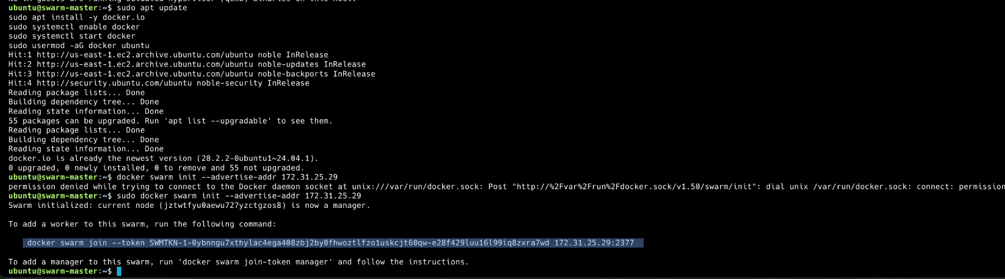

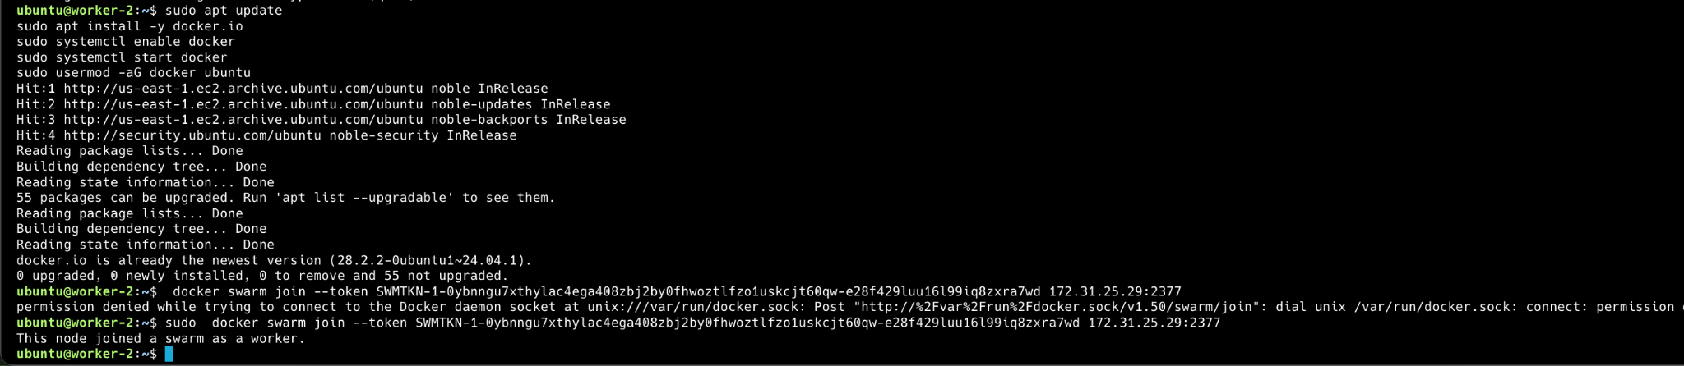

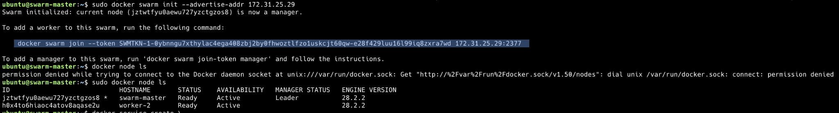

- Deploy a Simple Web Service in Docker Swarm
  - Deploy a Backend and Frontend app with 3 replicas
  - Verify the deployment using docker service ls and docker service ps web.
  - Submit screenshots of the running service.
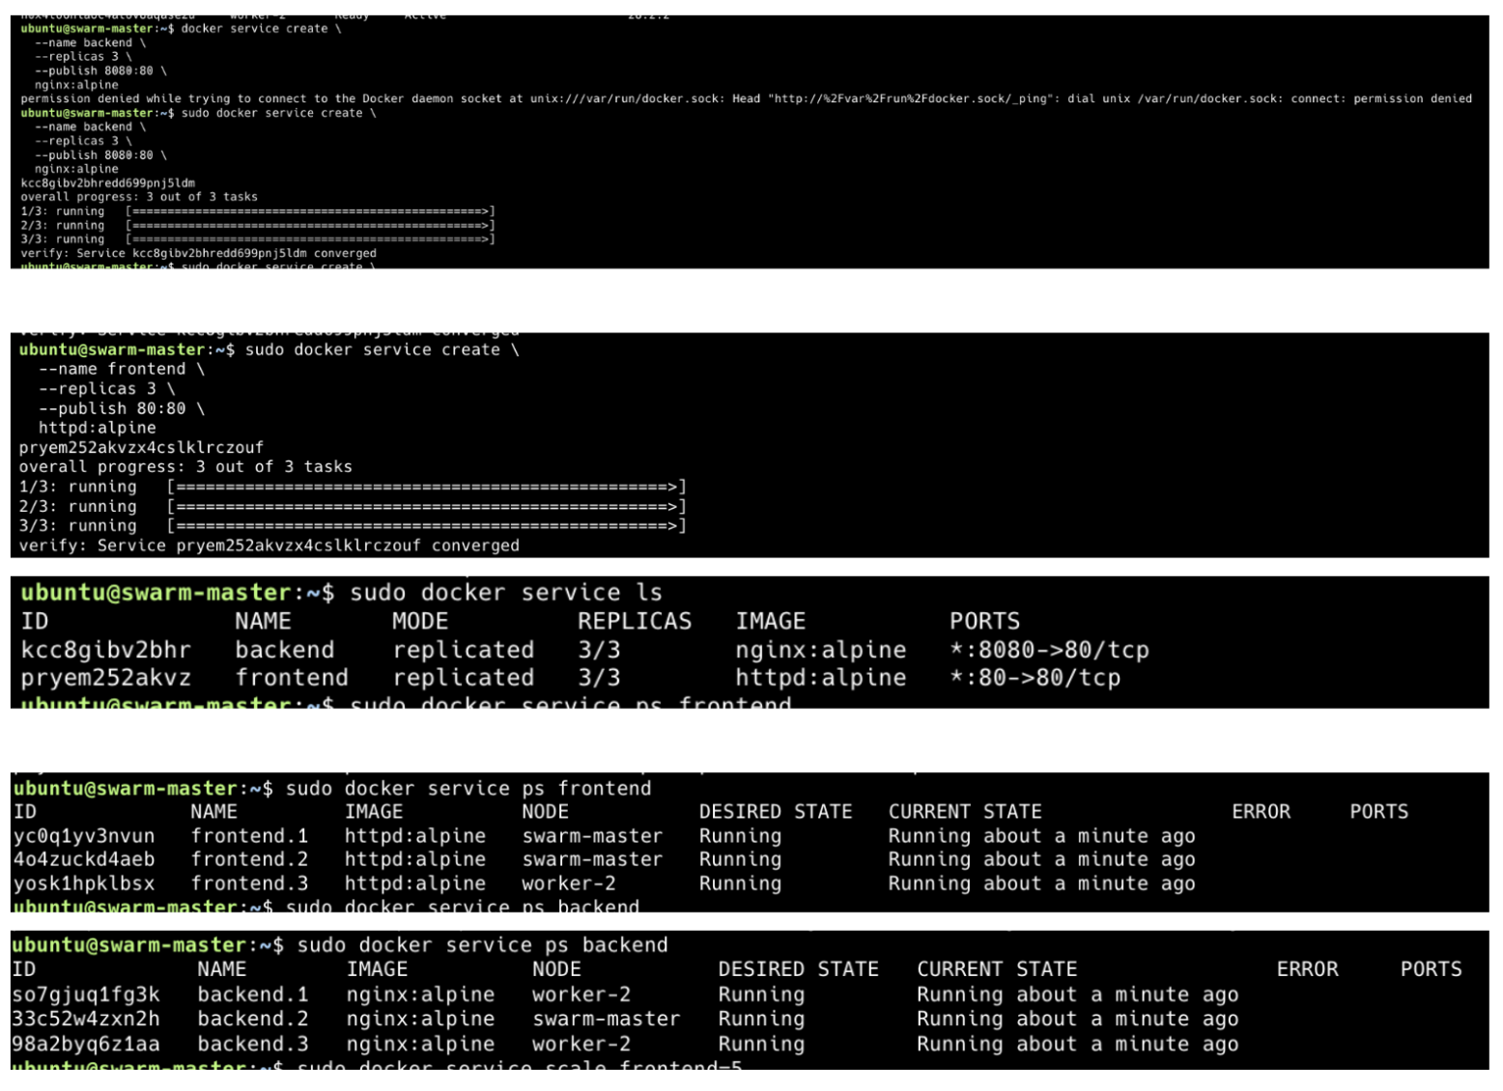
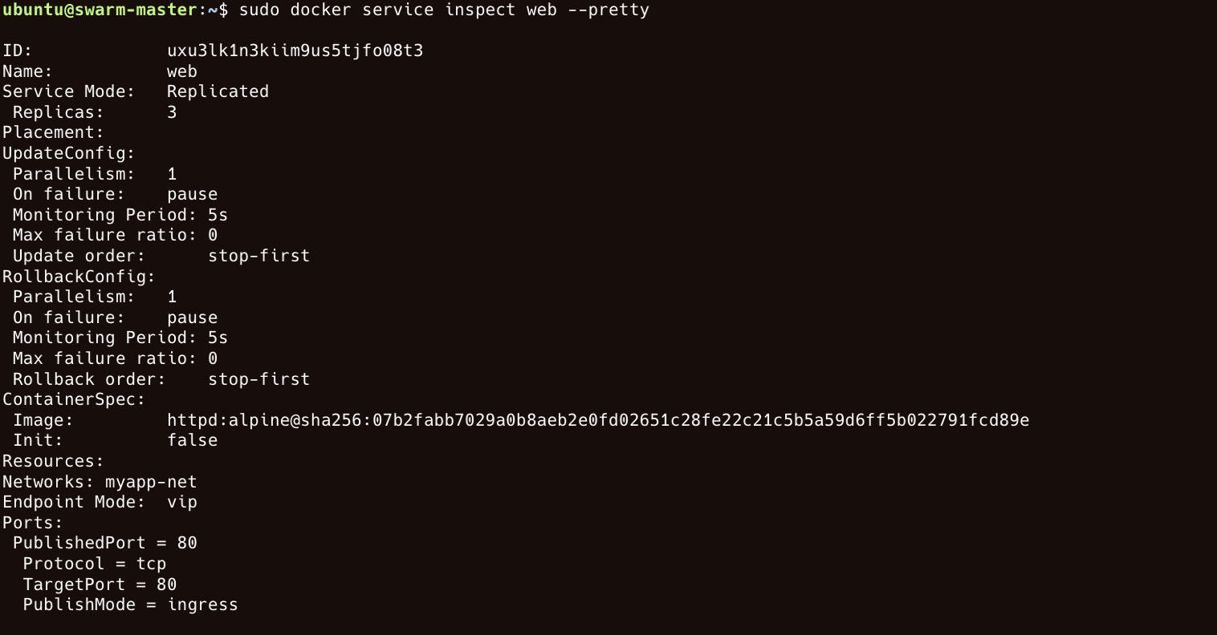

- Scaling and Updating a Service in Docker Swarm
  - Scale an existing service to 5 replicas (docker service scale web=5).
  - Update the service to use a new image version (docker service update --image nginx:latest web).
  - Submit outputs of docker service ls and docker service ps web.
